1. Create the following tables with the following attributes and constraints on them.

a. Bank (bk_code, bk_name, bk_address)

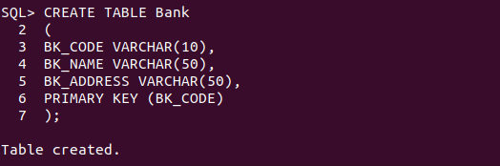

b. Branch (br_id, br_name, br_address, bk_code)
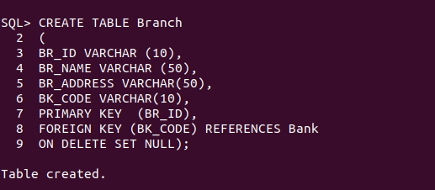

c. Customer (cust_ID, cust_name, phone_no, address)

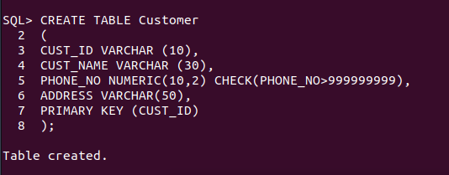

d. Account (acc_no, acc_type, balance, br_id)

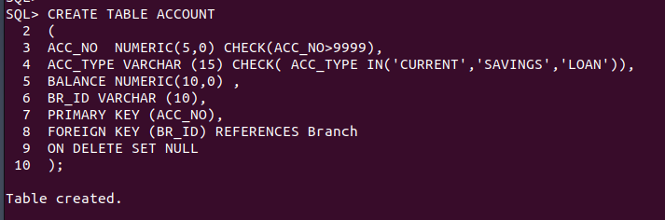
e. Customer_Account (cust_ID, acc_no)

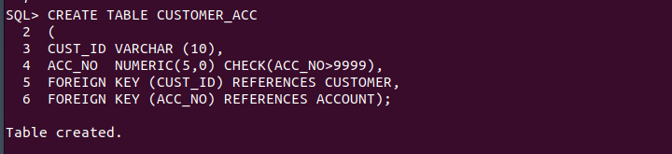

f. Loan (loan_ID, loan_type, amount, br_id)

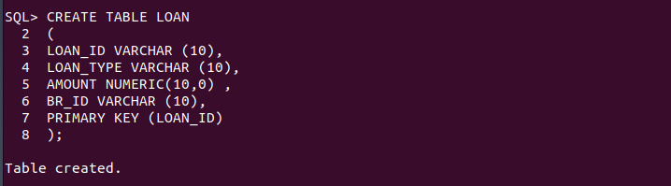

g. Customer_Loan (cust_ID, loan_ID)
